

CSE366: Artificial Intelligence (Section-x)
[Semester Year]

Project Report

Project/Application Title

Project URL/Link

Submitted by:

Student ID | Student Name | Contribution Percentage

The difference between maximum and minimum contribution among the students must be at least 10%. Remove this line when you prepare the report.

2. Abstract (Maximum 200 words)
- A brief, single-paragraph summary of the entire project.
- State the problem addressed, the algorithm/model used, the dataset (if applicable), the key results, and the main conclusion.

3. Introduction
3.1. Problem Definition
- Clearly state the specific problem or task the project aims to solve (e.g., finding the shortest path, classifying images, predicting house prices, etc.).
- Explain why this problem is relevant or challenging.
3.2. Project Goal and Scope
- What is the primary objective? (e.g., "The goal is to implement an A* search and compare its efficiency against Dijkstra's algorithm.")
- What are the limitations or boundaries of the project? (e.g., "The scope is limited to a binary classification task.")

4. Theoretical Background (Algorithm/Model)
4.1. Core Concept
- Explain the fundamental theory behind the chosen algorithm, model, or network architecture. (e.g., For A*, explain $f(n) = g(n) + h(n)$ and the role of the heuristic.)
- Provide necessary mathematical equations or formal definitions.
4.2. Implementation Details
- Describe the data structures and key components used in your implementation (e.g., Priority Queue for A*, Adjacency List for Graph, Hidden Layers and Activation Functions for ANN).

5. Methodology and Implementation
5.1. Dataset / Environment Setup
- For ML/NN Projects:
  - Describe the dataset used (Source, Size, Number of Features/Classes).
  - Explain the data preprocessing steps (e.g., normalization, feature scaling, one-hot encoding, train/validation/test split).
- For Algorithm Projects:
  - Describe the environment or simulation space (e.g., Grid World dimensions, Maze structure, state space).
  - Detail the cost function and, for heuristic-based search, the specific heuristic used.
5.2. Model/Algorithm Design
- For CNN/ANN: Include a diagram or table of the network architecture (e.g., layers, number of neurons, kernel size, output shape).
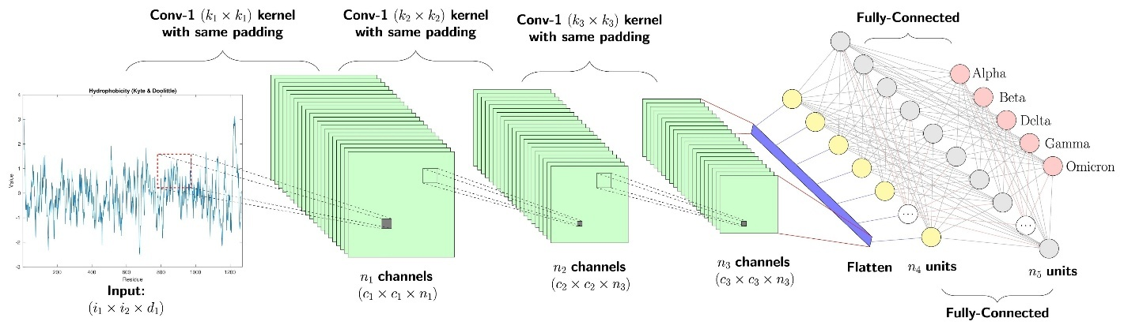
Shutterstock
- For ML Models: Detail the model parameters (e.g., Kernel for SVM, $\lambda$ for Regularization).
- For Search Algorithms: Describe the state representation, transition function, and goal test.
5.3. Implementation Language and Tools
- State the programming language(s) and libraries used (e.g., Python, NumPy, Scikit-learn, TensorFlow/PyTorch).

6. Results and Analysis
6.1. Experimental Setup
- What metrics were used for evaluation (e.g., Accuracy, Precision, Recall, F1-Score, Path Cost, Execution Time, Number of Nodes Explored)?
- How were the experiments conducted (e.g., 5-fold cross-validation, number of trials)?
6.2. Results Presentation
- Present the key quantitative results clearly, typically using Tables and/or Graphs.
  - Example Table: Compare your model's performance against a baseline or other algorithms.
  - Example Graph: Show the loss vs. epoch, or the runtime vs. problem size.
6.3. Discussion and Interpretation
- Analyze the results: What do the metrics tell you about the model's performance?
- Identify the strengths and weaknesses of your implementation.
- Error Analysis (Crucial): If the model performed poorly or if the algorithm failed in certain scenarios, explain why.

7. Conclusion
- Summarize the main findings of the project.
- Restate whether the original project goal (from Section 3.2) was achieved.
- What is the single most important takeaway from your project?

8. Future Work
- Suggest concrete ways to improve the current solution or extend the project. (e.g., "Future work will involve implementing a more informed heuristic," or "We plan to incorporate transfer learning.")

9. References (APA or IEEE Style)
- List all sources consulted, including papers, books, online documentation, and code repositories.

10. Appendix (Optional)
- Include code snippets (if requested), detailed hyperparameter lists, or large graphs/tables that clutter the main report body.

